**5 CARDS PROJECT PROPOSAl**

1. **Title**

Crazy 5 cards game

1. **Background and Motivation**

Crazy 5 cards is a game that is simple, it is played with a full deck of 52 cars excluding the jokers. There can be two players, but there can also be four players to play the game.

The players have to have five deck of cards each taken from the 52 deck of cards. Players have to sit opposite to each other so that they cannot see each other’s cards. In the card game a player have to have an ace or a ten and four cards to win, an ace or a ten, two cards of the same king and another two cards of the same kind to win, three cards of the same kind and two cards of the same kind to win. To obtain the cards to win they have to pick one card from the deck of cards and make a decision on which card to throw away from the players cards (5 + 1 = 6 cards), a player is supposed to have five (5) cards only. The other player can then choose which cad they would like to pick from the deck of cards or from the played cards and make a decision on which one to throw.

The players continue playing until one player wins.

Crazy 5 cards is for now known by the name “five cards”, there is no communication in the game, a player is only supposed to say something when that player have won otherwise there is no asking another player on which cards do they have.

Variations: * some people play that at the end of the deal the starts when the dealer says “GO”.

* The game only allow one person to pick a card at a time. The player must discard a card before picking up another.

1. Problem Statement

The aim of this version of crazy five cards game is to have an ace or a ten and four cards, an ace or a ten, two cards of the same king and another two cards of the same kind, three cards of the same kind and two cards of the same kind. This game has a medium complexity, features will be added in order to increase the game’s complexity and its attractiveness.

1. Approach

The aim of this project is to implement a car game in java with the following milestones:

First thing to do is to code, the code will contain four arrays of the cards, one for the 52 deck of cards minus 10 cards for the two players, another array for the played cards, two arrays each of five cards for each payer.

Two players can play the game at a time

A scoreboard is not needed since there can be only on stage of the game. A player who won is the player who won. GUI or our command line will be implementing to make and improve the attractiveness of the game

The work is going to be presented in the form of a GitHub code and project Document. The extensions will include a walkthrough of the steps through the SDLC that our group followed, and Visual Guide that shows the game in action. This will be represented in the form of ‘storyboards’ that will show the start and the end of the game.

1. Timeline

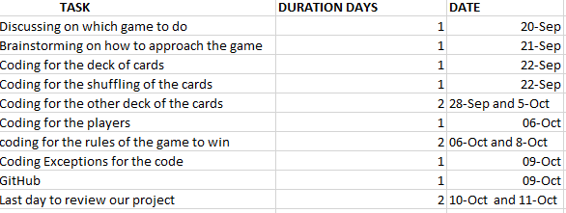

1. References
2. There are no references since we game up with the whole game. We made the came
3. Nobuhle, Kudzai and Brian.